**Java New Features**

**Java 7**

**Java <> Operator**

Before Java 7

Map<String, Integer> params = new HashMap<String, Integer>();

After Java 7

Map<String, Integer> params = new HashMap<>();

**try-with-resources**

Before Java 7

public class ResourceManagementBeforeJava7

{

    public static void main(String[] args)

    {

        BufferedReader br = null;

        try

        {

            String sCurrentLine;

            br = new BufferedReader(new FileReader(“C:/temp/test.txt”));

            while ((sCurrentLine = br.readLine()) != null)

            {

                System.out.println(sCurrentLine);

            }

        }

        catch (IOException e)

        {

            e.printStackTrace();

        }

        finally

        {

            try

            {

                if (br != null)

                    br.close();

            }

            catch (IOException ex) {

                ex.printStackTrace();

            }

        }

    }

}

After Java 7

public class ResourceManagementInJava7

{

    public static void main(String[] args)

    {

        try (BufferedReader br = new BufferedReader(new FileReader(“C:/temp/test.txt”)))

        {

            String sCurrentLine;

            while ((sCurrentLine = br.readLine()) != null)

            {

                System.out.println(sCurrentLine);

            }

        }

        catch (IOException e)

        {

            e.printStackTrace();

        }

    }

}

JDBC before Java 7

Connection con = null;

Statement stmt = null;

ResultSet rs = null;

//Registering the Driver

try {

   con = DriverManager.getConnection(mysqlUrl, "root", "password");

   stmt = con.createStatement();

} catch (SQLException e) {

   e.printStackTrace();

}   finally {

   try {

      rs.close();

      stmt.close();

      con.close();

   } catch(SQLException e) {

      e.printStackTrace();

   }

}

JDBC After Java 7

import java.sql.Connection;

import java.sql.DriverManager;

import java.sql.ResultSet;

import java.sql.SQLException;

import java.sql.Statement;

public class TryWithResources_Example {

   public static void main(String args[]) {

      String mysqlUrl = "jdbc:mysql://localhost/mydatabase";

      try(Connection con = DriverManager.getConnection(mysqlUrl, "root", "password");

      Statement stmt = con.createStatement(); ) {

         try(ResultSet rs = stmt.executeQuery("select * from MyPlayers");){

            while(rs.next()) {

               System.out.print(rs.getInt("ID")+", ");

               System.out.print(rs.getString("First_Name")+", ");

               System.out.print(rs.getString("Last_Name")+", ");

               System.out.print(rs.getDate("Date_Of_Birth")+", ");

               System.out.print(rs.getString("Place_Of_Birth")+", ");

               System.out.print(rs.getString("Country"));

            }

         } catch (SQLException e) {

            e.printStackTrace();

         }

      } catch (SQLException e) {

            e.printStackTrace();

      }

   }

}

**Multi Catch**

Before Java 7

**public** **class** MultipleExceptionExample{

**public** **static** **void** main(String args[]){

**try**{

**int** array[] = newint[10];

            array[10] = 30/0;

        }

**catch**(ArithmeticException e){

            System.out.println(e.getMessage());

        }

**catch**(ArrayIndexOutOfBoundsException e){

            System.out.println(e.getMessage());

        }

**catch**(Exception e){

            System.out.println(e.getMessage());

        }

     }

}

After Java 7

**public** **class** MultipleExceptionExample{

**public** **static** **void** main(String args[]){

**try**{

**int** array[] = newint[10];

            array[10] = 30/0;

        }

**catch**(ArithmeticException | ArrayIndexOutOfBoundsException e){

            System.out.println(e.getMessage());

        }

**catch**(Exception e){

            System.out.println(e.getMessage());

        }

     }

}

**java.util.Objects**

Most applications require an extensive hashing implementation, and writing a good hashing algorithm is always a tedious job. To get rid of this ugly and tedious hashCode and equals implementation, Java introduced an API called java.util.Objects in Java 7, which contains a set of utility methods and is useful in combination with Object instances.

Before Java 6

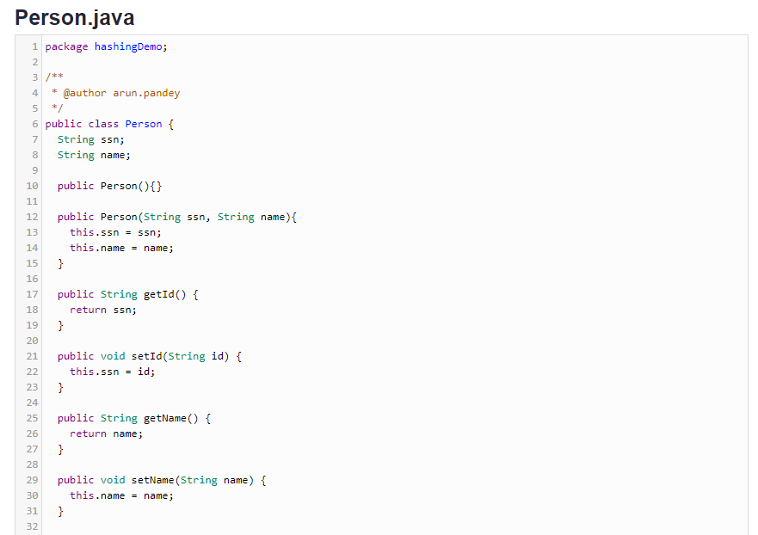

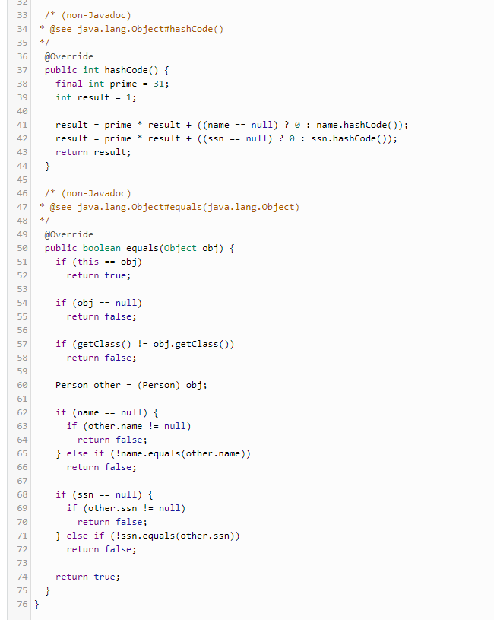

public class Person {

String ssn;

String name;

public Person(){}

public Person(String ssn, String name){

this.ssn = ssn;

this.name = name;

}

public String getId() {

return ssn;

}

public void setId(String id) {

this.ssn = id;

}

public String getName() {

return name;

}

public void setName(String name) {

this.name = name;

}

/* (non-Javadoc)

* @see java.lang.Object#hashCode()

*/

@Override

public int hashCode() {

final int prime = 31;

int result = 1;

result = prime * result + ((name == null) ? 0 : name.hashCode());

result = prime * result + ((ssn == null) ? 0 : ssn.hashCode());

return result;

}

/* (non-Javadoc)

* @see java.lang.Object#equals(java.lang.Object)

*/

@Override

public boolean equals(Object obj) {

if (this == obj)

return true;

if (obj == null)

return false;

if (getClass() != obj.getClass())

return false;

Person other = (Person) obj;

if (name == null) {

if (other.name != null)

return false;

} else if (!name.equals(other.name))

return false;

if (ssn == null) {

if (other.ssn != null)

return false;

} else if (!ssn.equals(other.ssn))

return false;

return true;

}

}

After Java 7

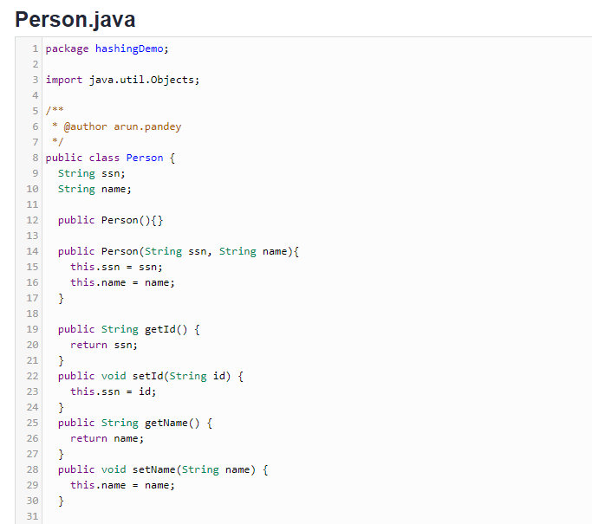

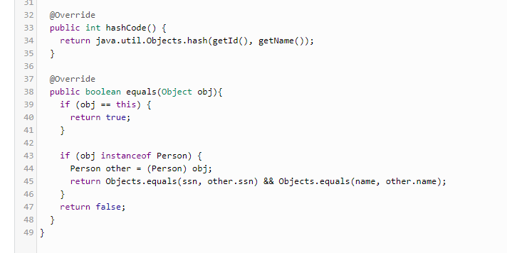

import java.util.Objects;

public class Person {

String ssn;

String name;

public Person(){}

public Person(String ssn, String name){

this.ssn = ssn;

this.name = name;

}

public String getId() {

return ssn;

}

public void setId(String id) {

this.ssn = id;

}

public String getName() {

return name;

}

public void setName(String name) {

this.name = name;

}

@Override

public int hashCode() {

return java.util.Objects.hash(getId(), getName());

}

@Override

public boolean equals(Object obj){

if (obj == this) {

return true;

}

if (obj instanceof Person) {

Person other = (Person) obj;

return Objects.equals(ssn, other.ssn) && Objects.equals(name, other.name);

}

return false;

}

}

HashingTest.java

import org.apache.commons.logging.Log;

import org.apache.commons.logging.LogFactory;

import org.junit.Test;

import junit.framework.Assert;

public class HashingTest {

public static final Log LOG = LogFactory.getLog(HashingTest.class);

@Test

public void testHashing() {

Person person1 = new Person("xxxx123", "Person1");

Person person2 = new Person("xxxx234", "Person2");

LOG.info("person1 HashCode ==>> " +person1.hashCode());

LOG.info("person2 HashCode ==>> " +person2.hashCode());

Assert.assertFalse(person1.hashCode() == person2.hashCode());

Assert.assertFalse("Both are same employee...", person1.equals(person2));

Person person3 = new Person("xxxx567", "Person3");

Person person4 = new Person("xxxx567", "Person4");

LOG.info("person3 HashCode ==>> " +person3.hashCode());

LOG.info("person4 HashCode ==>> " +person4.hashCode());

Assert.assertEquals(person3.hashCode(), person4.hashCode());

Assert.assertTrue("Both are not same employee...",person3.equals(person4));

}

}

**Java 8**

**Lambda expressions**

Lambda expression is a new feature which is introduced in Java 8. A lambda expression is an **anonymous function**. A function that doesn’t have a name and doesn’t belong to any class. The concept of lambda expression was first introduced in LISP programming language.

**Java Lambda Expression Syntax**

To create a lambda expression, we specify input parameters (if there are any) on the left side of the lambda operator ->, and place the expression or block of statements on the right side of lambda operator.

For example, the lambda expression

(x, y) -> x + y

specifies that lambda expression takes two arguments x and y and returns the sum of these.



**Lambda expression vs method in Java**

A method (or function) in Java has these main parts:

1. Name  
2. Parameter list  
3. Body  
4. return type.

A lambda expression in Java has these main parts:

Lambda expression **only has body and parameter list**.

1. **No name** – function is anonymous so we don’t care about the name  
   2. Parameter list  
   3. Body – This is the main part of the function.  
   4. **No return type** – The java 8 compiler is able to infer the return type by checking the code. you need not to mention it explicitly.

**Where to use the Lambdas in Java**

To use lambda expression, you need to either create your own functional interface or use the pre defined functional interface provided by Java. An interface **with only single abstract method** is called functional interface(or Single Abstract method interface), for example: Runnable, callable, ActionListener etc.

**To use function interface:**

**Pre Java 8:** We create anonymous inner classes.  
**Post Java 8:** You can use lambda expression instead of anonymous inner classes.

**Java Lambda expression Example**

**Without using Lambda expression**: Prior to java 8 we used the anonymous inner class to implement the only abstract method of functional interface.

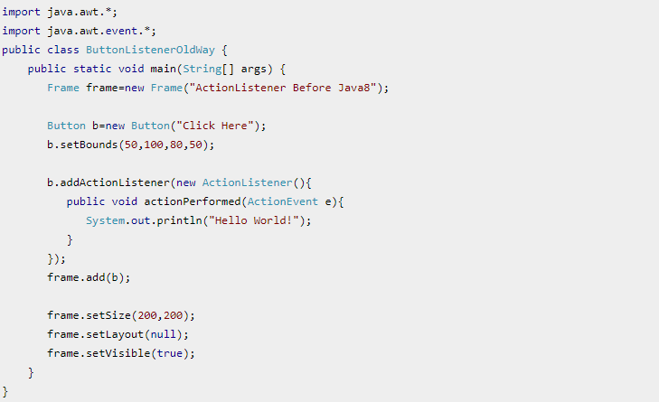

import java.awt.*;

import java.awt.event.*;

public class ButtonListenerOldWay {

public static void main(String[] args) {

Frame frame=new Frame("ActionListener Before Java8");

Button b=new Button("Click Here");

b.setBounds(50,100,80,50);

b.addActionListener(new ActionListener(){

public void actionPerformed(ActionEvent e){

System.out.println("Hello World!");

}

});

frame.add(b);

frame.setSize(200,200);

frame.setLayout(null);

frame.setVisible(true);

}

}

**By using Lambda expression**: Instead of creating anonymous inner class, we can create a lambda expression like this:

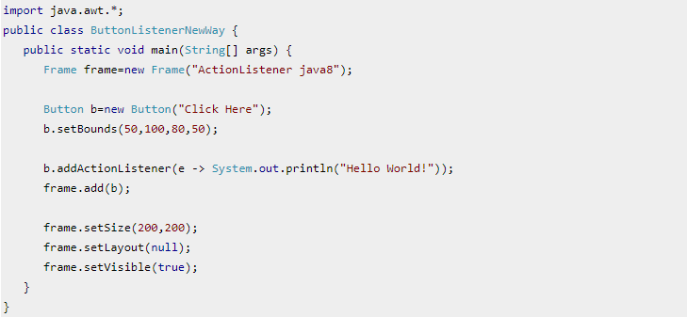

import java.awt.*;

public class ButtonListenerNewWay {

public static void main(String[] args) {

Frame frame=new Frame("ActionListener java8");

Button b=new Button("Click Here");

b.setBounds(50,100,80,50);

b.addActionListener(e -> System.out.println("Hello World!"));

frame.add(b);

frame.setSize(200,200);

frame.setLayout(null);

frame.setVisible(true);

}

}

**Note:** As you can see that we used less code with lambda expression.

Lets see few more examples of Lambda expressions.

**Example 1: Java Lambda Expression with no parameter**

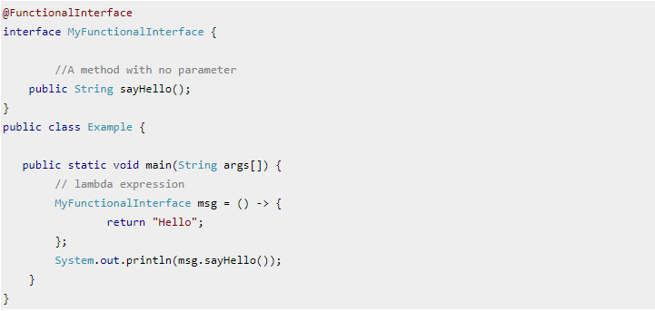

@FunctionalInterface

interface MyFunctionalInterface {

//A method with no parameter

public String sayHello();

}

public class Example {

public static void main(String args[]) {

// lambda expression

MyFunctionalInterface msg = () -> {

return "Hello";

};

System.out.println(msg.sayHello());

}

}

**Example 2: Java Lambda Expression with single parameter**

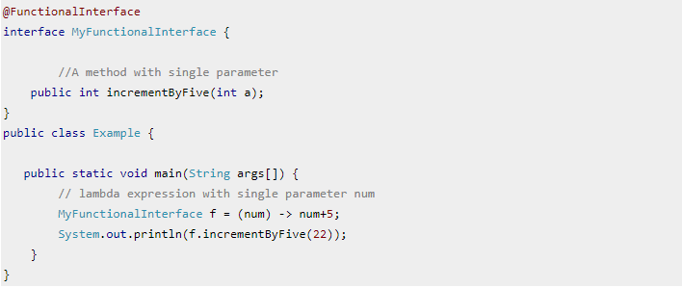

@FunctionalInterface

interface MyFunctionalInterface {

//A method with single parameter

public int incrementByFive(int a);

}

public class Example {

public static void main(String args[]) {

// lambda expression with single parameter num

MyFunctionalInterface f = (num) -> num+5;

System.out.println(f.incrementByFive(22));

}

}

**Example 3: Java Lambda Expression with Multiple Parameters**

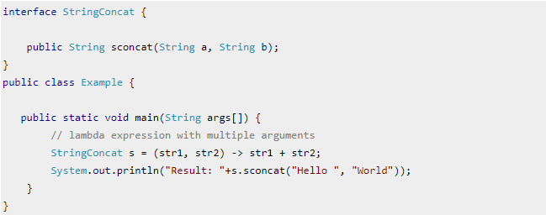

interface StringConcat {

public String sconcat(String a, String b);

}

public class Example {

public static void main(String args[]) {

// lambda expression with multiple arguments

StringConcat s = (str1, str2) -> str1 + str2;

System.out.println("Result: "+s.sconcat("Hello ", "World"));

}

}

**Example 4: Iterating collections using foreach loop**

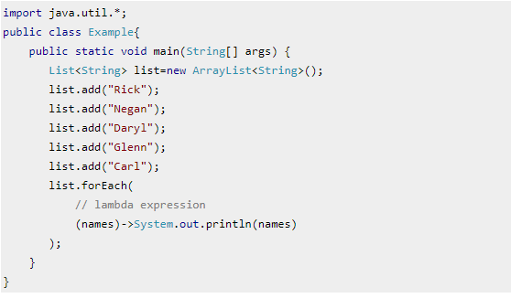

import java.util.*;

public class Example{

public static void main(String[] args) {

List<String> list=new ArrayList<String>();

list.add("Rick");

list.add("Negan");

list.add("Daryl");

list.add("Glenn");

list.add("Carl");

list.forEach(

// lambda expression

(names)->System.out.println(names)

);

}

}

**Example 5: Iterating Map in Java 8 using Lambda expression**

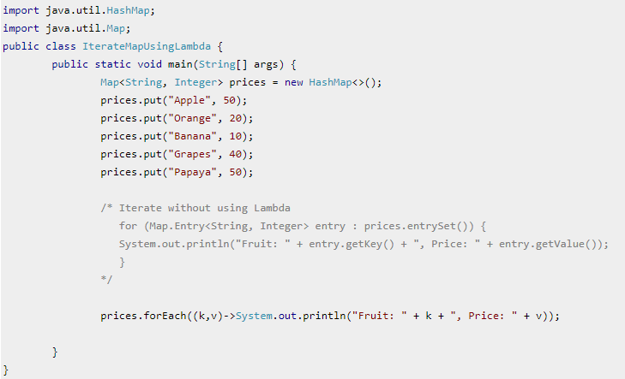

import java.util.HashMap;

import java.util.Map;

public class IterateMapUsingLambda {

public static void main(String[] args) {

Map<String, Integer> prices = new HashMap<>();

prices.put("Apple", 50);

prices.put("Orange", 20);

prices.put("Banana", 10);

prices.put("Grapes", 40);

prices.put("Papaya", 50);

/* Iterate without using Lambda

for (Map.Entry<String, Integer> entry : prices.entrySet()) {

System.out.println("Fruit: " + entry.getKey() + ", Price: " + entry.getValue());

}

*/

prices.forEach((k,v)->System.out.println("Fruit: " + k + ", Price: " + v));

}

}

**Example 6: Iterating List in Java 8 using Lambda expression**

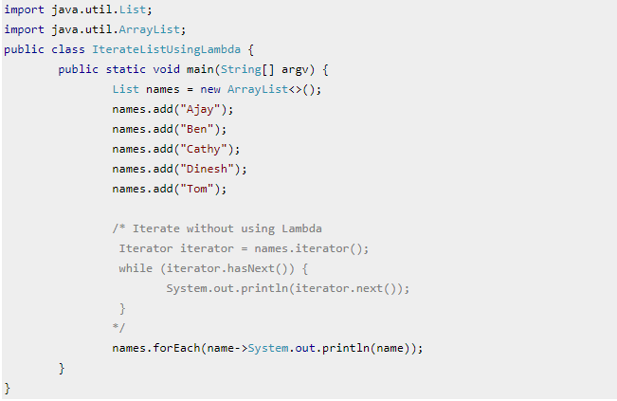

import java.util.List;

import java.util.ArrayList;

public class IterateListUsingLambda {

public static void main(String[] argv) {

List names = new ArrayList<>();

names.add("Ajay");

names.add("Ben");

names.add("Cathy");

names.add("Dinesh");

names.add("Tom");

/* Iterate without using Lambda

Iterator iterator = names.iterator();

while (iterator.hasNext()) {

System.out.println(iterator.next());

}

*/

names.forEach(name->System.out.println(name));

}

}

**Method reference**

Method reference is a shorthand notation of a lambda expression to call a method.

For example:

If your lambda expression is like this:



then you can replace it with a method reference like this:



The :: operator is used in method reference to separate the class or object from the method name

**Four types of method references**

1. Method reference to an instance method of an object – object::instanceMethod

2. Method reference to a static method of a class – Class::staticMethod

3. Method reference to an instance method of an arbitrary object of a particular type – Class::instanceMethod

4. Method reference to a constructor – Class::new

1. **Method reference to an instance method of an object**

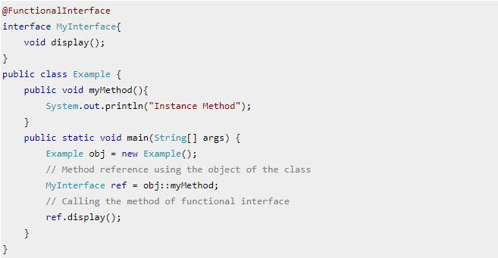

@FunctionalInterface

interface MyInterface{

void display();

}

public class Example {

public void myMethod(){

System.out.println("Instance Method");

}

public static void main(String[] args) {

Example obj = new Example();

// Method reference using the object of the class

MyInterface ref = obj::myMethod;

// Calling the method of functional interface

ref.display();

}

}

1. **Method reference to a static method of a class**

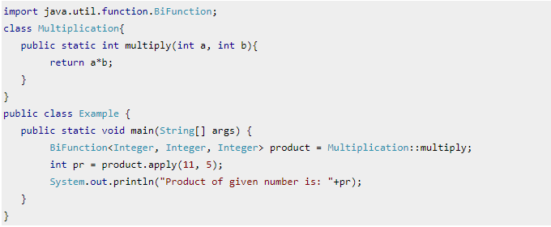

import java.util.function.BiFunction;

class Multiplication{

public static int multiply(int a, int b){

return a*b;

}

}

public class Example {

public static void main(String[] args) {

BiFunction<Integer, Integer, Integer> product = Multiplication::multiply;

int pr = product.apply(11, 5);

System.out.println("Product of given number is: "+pr);

}

}

1. **Method reference to an instance method of an arbitrary object of a particular type**

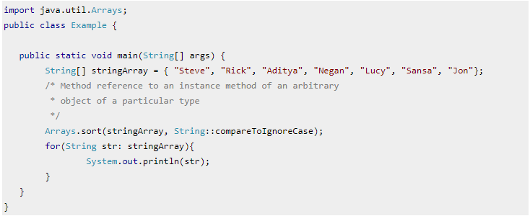

import java.util.Arrays;

public class Example {

public static void main(String[] args) {

String[] stringArray = { "Steve", "Rick", "Aditya", "Negan", "Lucy", "Sansa", "Jon"};

/* Method reference to an instance method of an arbitrary

* object of a particular type

*/

Arrays.sort(stringArray, String::compareToIgnoreCase);

for(String str: stringArray){

System.out.println(str);

}

}

}

1. **Method reference to a constructor**

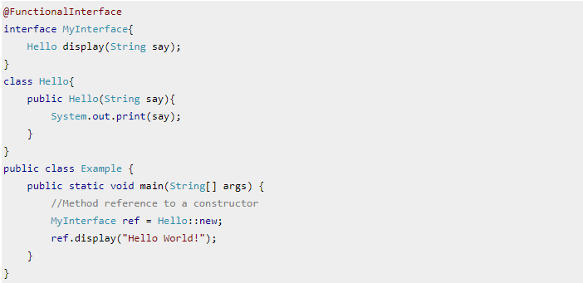

@FunctionalInterface

interface MyInterface{

Hello display(String say);

}

class Hello{

public Hello(String say){

System.out.print(say);

}

}

public class Example {

public static void main(String[] args) {

//Method reference to a constructor

MyInterface ref = Hello::new;

ref.display("Hello World!");

}

}

**Functional Interface**

An interface with only single abstract method is called functional interface. You can either use the predefined functional interface provided by Java or create your own functional interface and use it. **Functional interfaces all have only one abstract method**. That is the reason,they are also known as Single Abstract Method interfaces (SAM Interfaces).

**To use lambda expression in Java, you need to either create your own functional interface or use the pre defined functional interface provided by Java**.

While creating your own functional interface, mark it with @FunctionalInterface annotation, this annotation is introduced in Java 8. Although its optional, you should use it so that you get a compilation error if the interface you marked with this annotation is not following the rules of functional interfaces.

**What are the rules of defining a functional interface?**

The functional interface should have **Only one abstract method**. Along with the one abstract method, they can have any number of default and static methods.

**Example 1: Creating your own functional interface**

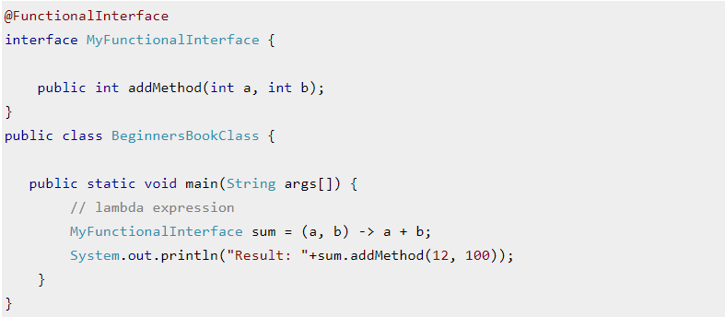

@FunctionalInterface

interface MyFunctionalInterface {

public int addMethod(int a, int b);

}

public class BeginnersBookClass {

public static void main(String args[]) {

// lambda expression

MyFunctionalInterface sum = (a, b) -> a + b;

System.out.println("Result: "+sum.addMethod(12, 100));

}

}

**Example 2: Using predefined functional interface**

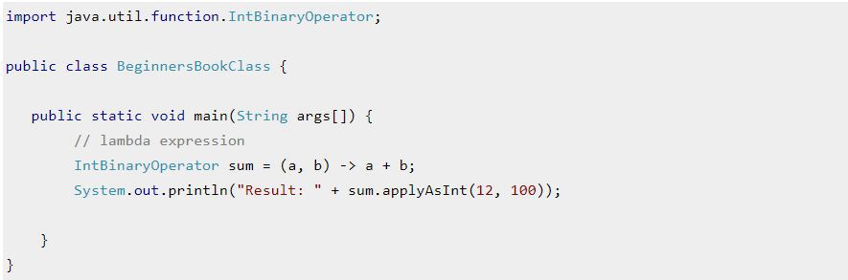

import java.util.function.IntBinaryOperator;

public class BeginnersBookClass {

public static void main(String args[]) {

// lambda expression

IntBinaryOperator sum = (a, b) -> a + b;

System.out.println("Result: " + sum.applyAsInt(12, 100));

}

}

**Functional interface example: using anonymous inner class vs using lambda expression**

We have been using functional interfaces even prior to java8, they were used by creating anonymous inner classes using these interfaces. You must have seen functional interfaces such as Runnable, ActionListener, Comparator etc. They all have single abstract method.

Lets see an example of ActionListener to see how it was used with Anonymous inner class and how it can be implemented using lambda expression.

**ActionListener Example: Before Java 8: Using anonymous inner class**

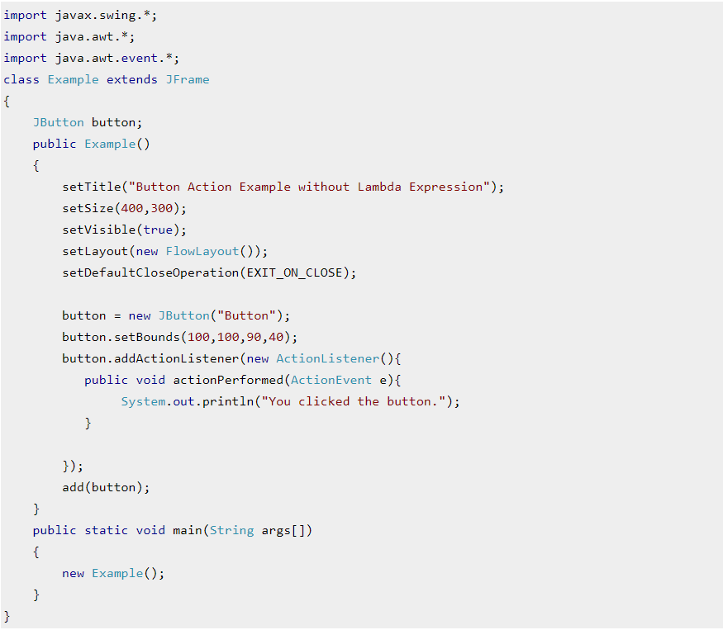

import javax.swing.*;

import java.awt.*;

import java.awt.event.*;

class Example extends JFrame

{

JButton button;

public Example()

{

setTitle("Button Action Example without Lambda Expression");

setSize(400,300);

setVisible(true);

setLayout(new FlowLayout());

setDefaultCloseOperation(EXIT_ON_CLOSE);

button = new JButton("Button");

button.setBounds(100,100,90,40);

button.addActionListener(new ActionListener(){

public void actionPerformed(ActionEvent e){

System.out.println("You clicked the button.");

}

});

add(button);

}

public static void main(String args[])

{

new Example();

}

}

**ActionListener Example: Lambda Expression**

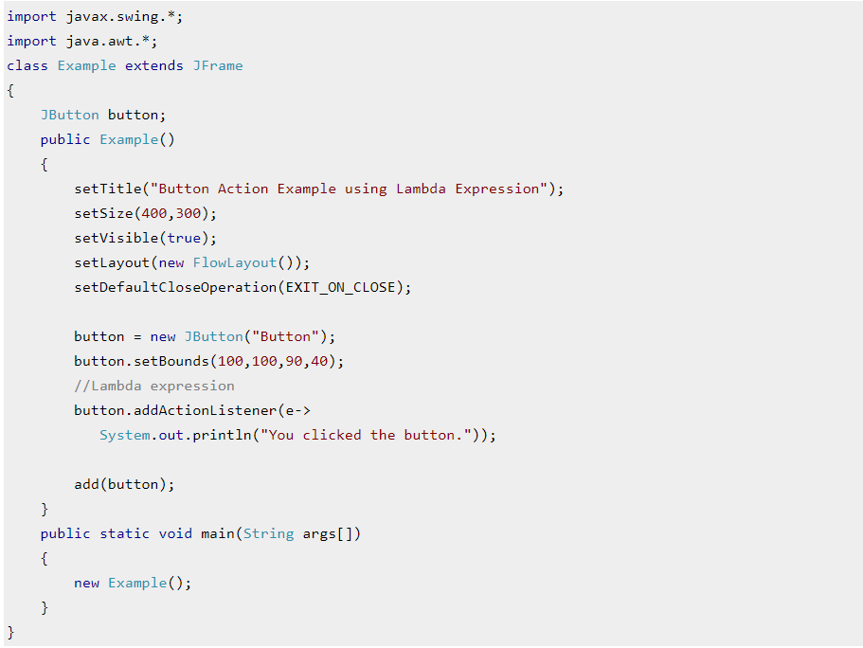

import javax.swing.*;

import java.awt.*;

class Example extends JFrame

{

JButton button;

public Example()

{

setTitle("Button Action Example using Lambda Expression");

setSize(400,300);

setVisible(true);

setLayout(new FlowLayout());

setDefaultCloseOperation(EXIT_ON_CLOSE);

button = new JButton("Button");

button.setBounds(100,100,90,40);

//Lambda expression

button.addActionListener(e->

System.out.println("You clicked the button."));

add(button);

}

public static void main(String args[])

{

new Example();

}

}

**Java Predefined-Functional Interfaces**

Java provides predefined functional interfaces to deal with functional programming by using lambda and method references.

You can also define your own custom functional interface. Following is the list of functional interface which are placed in java.util.function package.

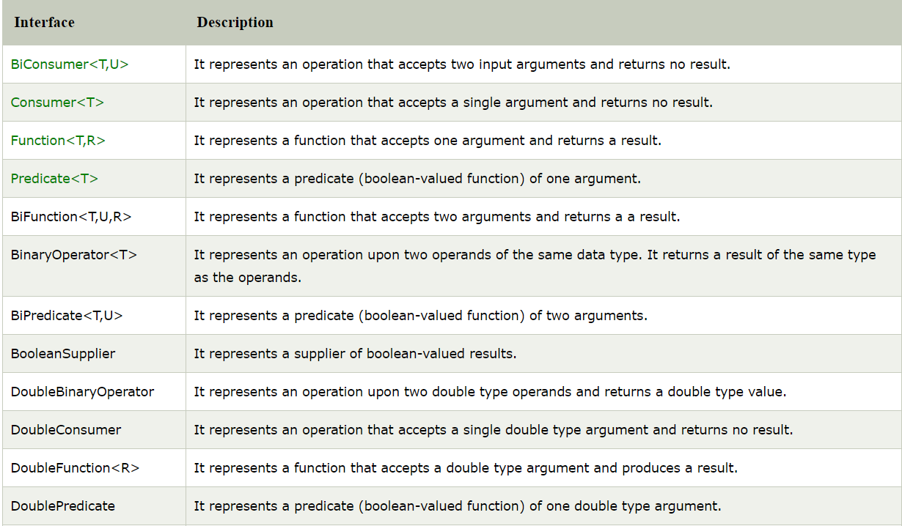

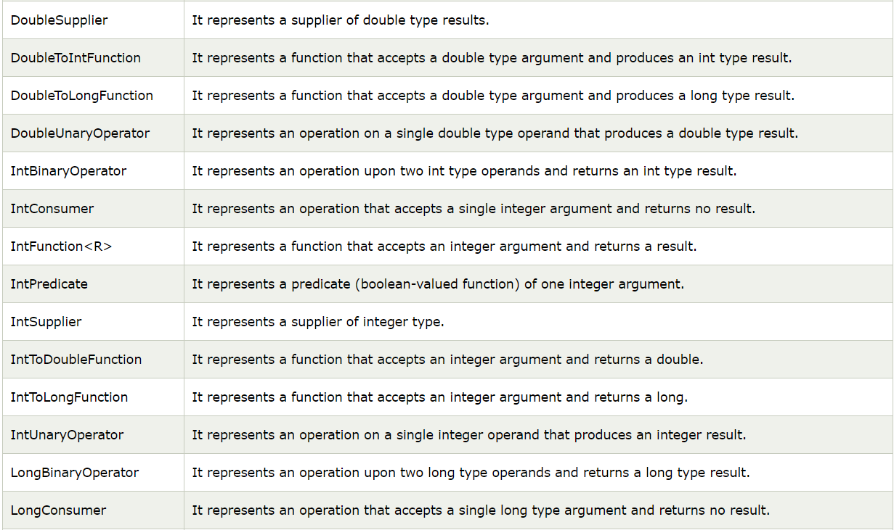

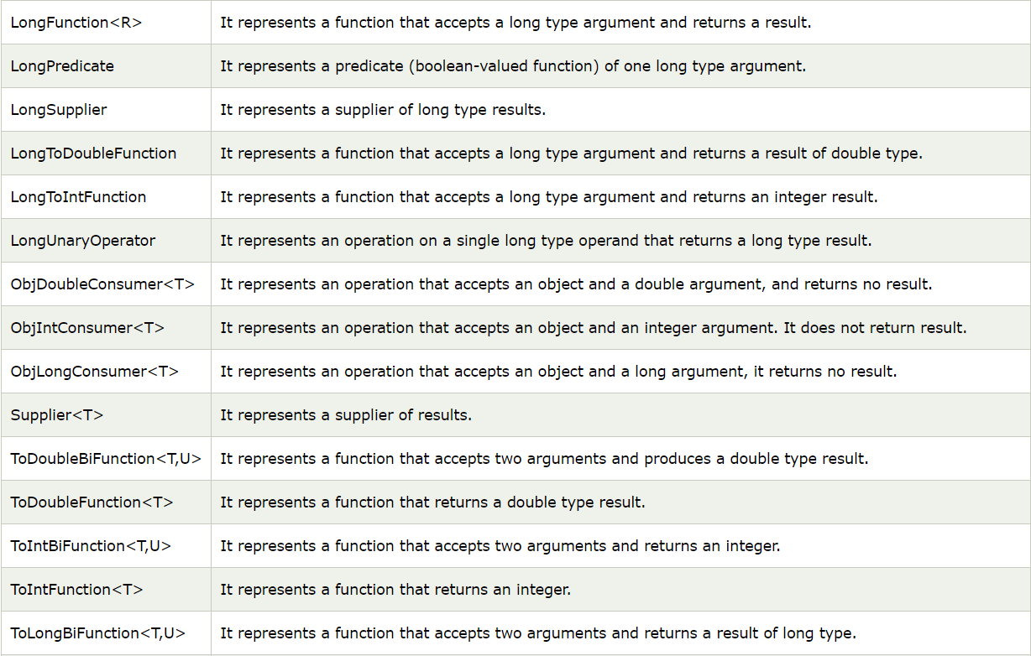



**Stream API**

Stream API is another new feature of java 8. All the classes and interfaces of this API is in the **java.util.stream** package. By using streams we can perform various aggregate operations on the data returned from collections, arrays, Input/Output operations.

Before we see how stream API can be used in Java, let’s see an example to understand the use of streams.

**Java Stream Example**

To understand how stream works, lets take an example without using stream and then we will see the same example with streams.

**Finding certain strings without using Stream**

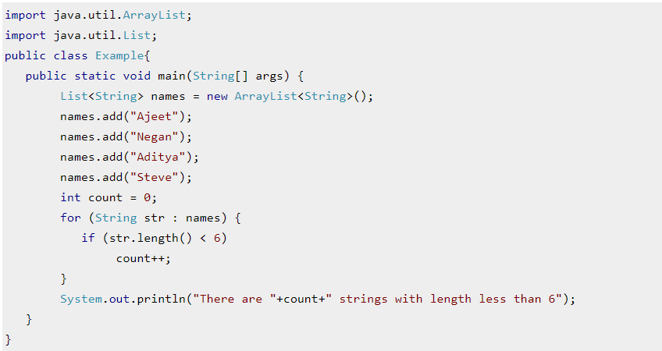

import java.util.ArrayList;

import java.util.List;

public class Example{

public static void main(String[] args) {

List<String> names = new ArrayList<String>();

names.add("Ajeet");

names.add("Negan");

names.add("Aditya");

names.add("Steve");

int count = 0;

for (String str : names) {

if (str.length() < 6)

count++;

}

System.out.println("There are "+count+" strings with length less than 6");

}

}

**Same example using Stream**

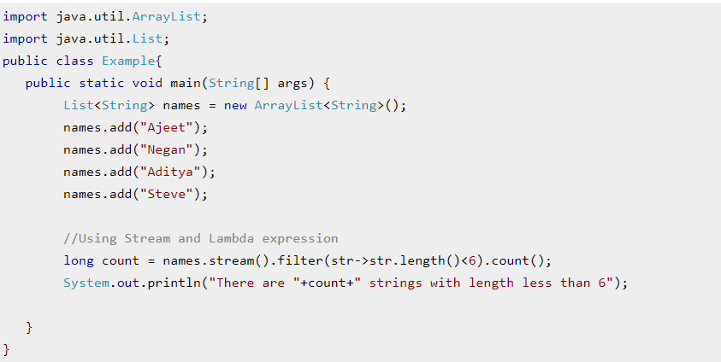

import java.util.ArrayList;

import java.util.List;

public class Example{

public static void main(String[] args) {

List<String> names = new ArrayList<String>();

names.add("Ajeet");

names.add("Negan");

names.add("Aditya");

names.add("Steve");

//Using Stream and Lambda expression

long count = names.stream().filter(str->str.length()<6).count();

System.out.println("There are "+count+" strings with length less than 6");

}

}

**How to work with Stream in Java**

Working of stream can be explained in three stages:

1. Create a stream

2. Perform **intermediate operations** on the initial stream to transform it into another stream and so on on further intermediate operations. In the above example, the filter() operation is intermediate operation, there can be more than one intermediate operations.

3. Perform **terminal operation** on the final stream to get the result. In the above example, the count() operation is terminal operation.

**Java Stream Features**

1. Stream **does not store** the elements. it simply performs the aggregate operations(such as filter() and count() that we have seen in the above example) to get the desired stream of data.

2. The aggregate operations that we perform on the collection, array or any other data source **do not change** the data of the source, they simply return a new stream. For example the code we have seen above is filtering the strings with length less than 6 using the stream operations but it didn’t change the elements of the list.

3. All the stream operations are **lazy** in nature which means they are not executed until they are needed. For example, if we want to display only the first 2 elements of a list using stream, the stream operation would stop at the end of second iteration after displaying the second element of list.

Let’s see few examples of Java Stream:

Java Stream Example 1: Iterating and displaying selected integers

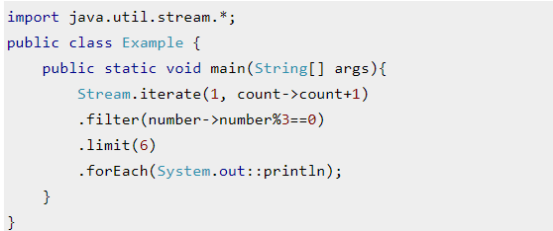

import java.util.stream.*;

public class Example {

public static void main(String[] args){

Stream.iterate(1, count->count+1)

.filter(number->number%3==0)

.limit(6)

.forEach(System.out::println);

}

}

**Java Stream Example 2: Concatenating two streams**

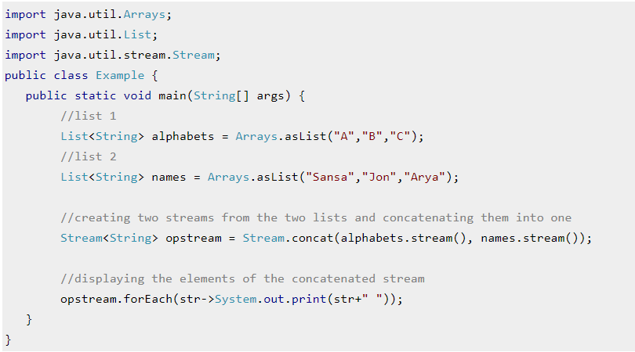

import java.util.Arrays;

import java.util.List;

import java.util.stream.Stream;

public class Example {

public static void main(String[] args) {

//list 1

List<String> alphabets = Arrays.asList("A","B","C");

//list 2

List<String> names = Arrays.asList("Sansa","Jon","Arya");

//creating two streams from the two lists and concatenating them into one

Stream<String> opstream = Stream.concat(alphabets.stream(), names.stream());

//displaying the elements of the concatenated stream

opstream.forEach(str->System.out.print(str+" "));

}

}

**Stream Filter**

The filter() is an intermediate operation that reads the data from a stream and returns a new stream after transforming the data based on the given condition.

**A Simple Example of Java Stream Filter()**

In this example we are creating a stream from the list of names using stream() method and then we are creating another stream of long names using stream filter(). As I mentioned above, the stream filter transforms the data of one stream into another stream.

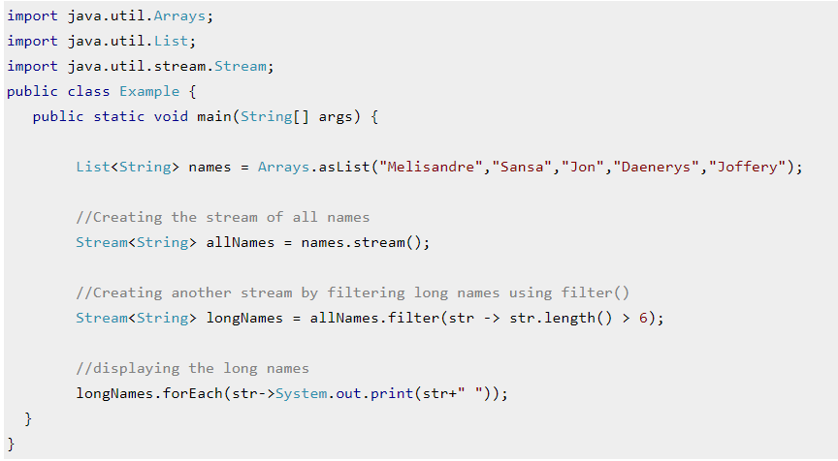

import java.util.Arrays;

import java.util.List;

import java.util.stream.Stream;

public class Example {

public static void main(String[] args) {

List<String> names = Arrays.asList("Melisandre","Sansa","Jon","Daenerys","Joffery");

//Creating the stream of all names

Stream<String> allNames = names.stream();

//Creating another stream by filtering long names using filter()

Stream<String> longNames = allNames.filter(str -> str.length() > 6);

//displaying the long names

longNames.forEach(str->System.out.print(str+" "));

}

}

**Example 1: Stream filter() and collect()**

We can create a stream and apply a filter in a one line as shown in the example below. The collect() method here collects the final stream and converts it into a list.

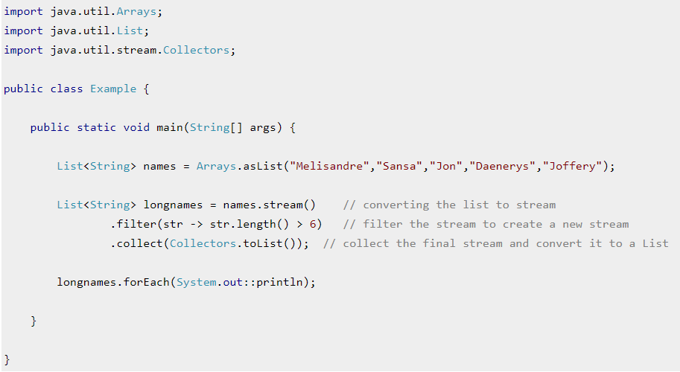

import java.util.Arrays;

import java.util.List;

import java.util.stream.Collectors;

public class Example {

public static void main(String[] args) {

List<String> names = Arrays.asList("Melisandre","Sansa","Jon","Daenerys","Joffery");

List<String> longnames = names.stream() // converting the list to stream

.filter(str -> str.length() > 6) // filter the stream to create a new stream

.collect(Collectors.toList()); // collect the final stream and convert it to a List

longnames.forEach(System.out::println);

}

}

**Example 2: Stream filter() with multiple conditions**

We can have more than one conditions in the filter() method joined using the logical operators in java. In the following example, we have two conditions in the filter method joined using and (&&) logical operator.

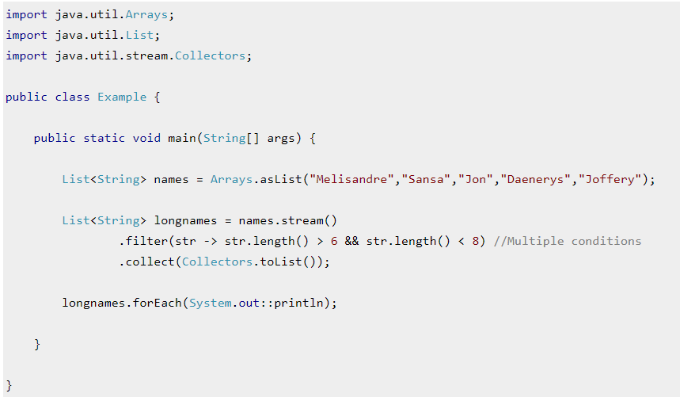

import java.util.Arrays;

import java.util.List;

import java.util.stream.Collectors;

public class Example {

public static void main(String[] args) {

List<String> names = Arrays.asList("Melisandre","Sansa","Jon","Daenerys","Joffery");

List<String> longnames = names.stream()

.filter(str -> str.length() > 6 && str.length() < 8) //Multiple conditions

.collect(Collectors.toList());

longnames.forEach(System.out::println);

}

}

**Example 3: Stream filter() and map() method in Java**

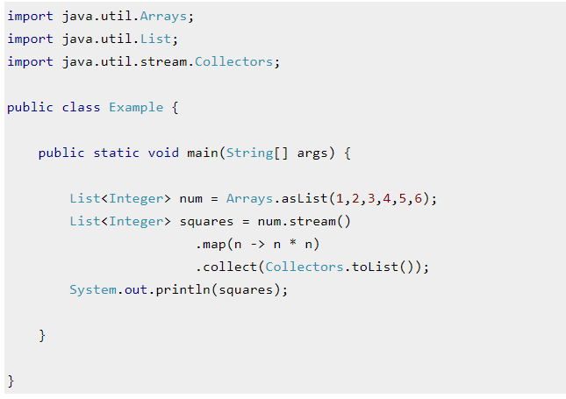

import java.util.Arrays;

import java.util.List;

import java.util.stream.Collectors;

public class Example {

public static void main(String[] args) {

List<Integer> num = Arrays.asList(1,2,3,4,5,6);

List<Integer> squares = num.stream()

.map(n -> n * n)

.collect(Collectors.toList());

System.out.println(squares);

}

}

**Example 4: Filter Map by Keys**

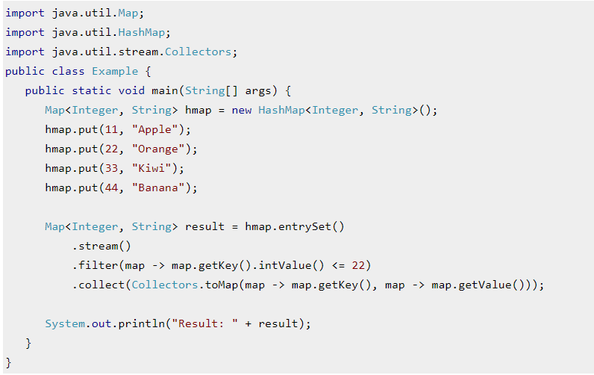

import java.util.Map;

import java.util.HashMap;

import java.util.stream.Collectors;

public class Example {

public static void main(String[] args) {

Map<Integer, String> hmap = new HashMap<Integer, String>();

hmap.put(11, "Apple");

hmap.put(22, "Orange");

hmap.put(33, "Kiwi");

hmap.put(44, "Banana");

Map<Integer, String> result = hmap.entrySet()

.stream()

.filter(map -> map.getKey().intValue() <= 22)

.collect(Collectors.toMap(map -> map.getKey(), map -> map.getValue()));

System.out.println("Result: " + result);

}

}

**Example 5: Filter Map by Values**

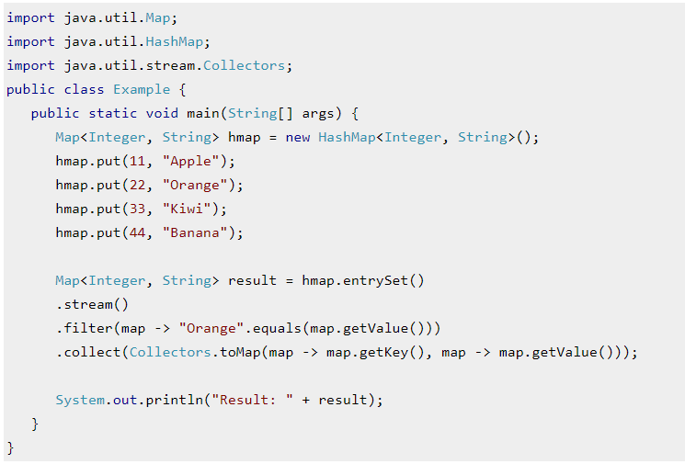

import java.util.Map;

import java.util.HashMap;

import java.util.stream.Collectors;

public class Example {

public static void main(String[] args) {

Map<Integer, String> hmap = new HashMap<Integer, String>();

hmap.put(11, "Apple");

hmap.put(22, "Orange");

hmap.put(33, "Kiwi");

hmap.put(44, "Banana");

Map<Integer, String> result = hmap.entrySet()

.stream()

.filter(map -> "Orange".equals(map.getValue()))

.collect(Collectors.toMap(map -> map.getKey(), map -> map.getValue()));

System.out.println("Result: " + result);

}

}

**Example 6:Filter Map by both Keys and Values**

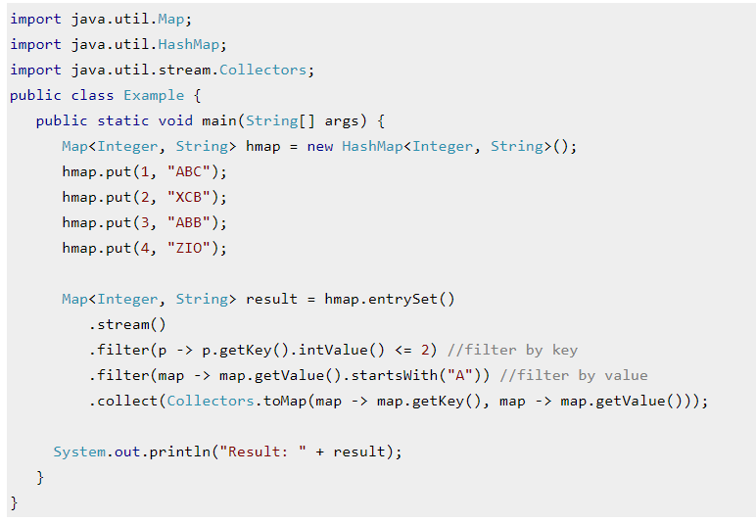

import java.util.Map;

import java.util.HashMap;

import java.util.stream.Collectors;

public class Example {

public static void main(String[] args) {

Map<Integer, String> hmap = new HashMap<Integer, String>();

hmap.put(1, "ABC");

hmap.put(2, "XCB");

hmap.put(3, "ABB");

hmap.put(4, "ZIO");

Map<Integer, String> result = hmap.entrySet()

.stream()

.filter(p -> p.getKey().intValue() <= 2) //filter by key

.filter(map -> map.getValue().startsWith("A")) //filter by value

.collect(Collectors.toMap(map -> map.getKey(), map -> map.getValue()));

System.out.println("Result: " + result);

}

}

**Example 7: A stream with null values**

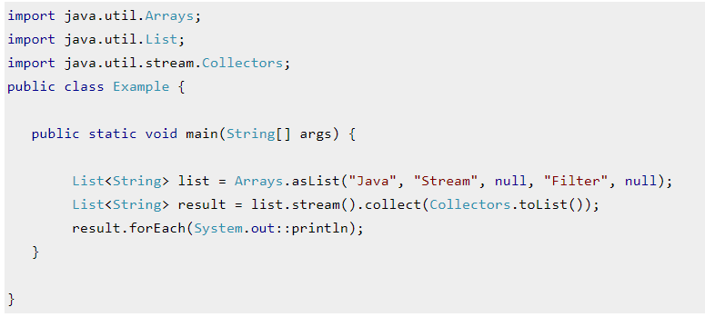

import java.util.Arrays;

import java.util.List;

import java.util.stream.Collectors;

public class Example {

public static void main(String[] args) {

List<String> list = Arrays.asList("Java", "Stream", null, "Filter", null);

List<String> result = list.stream().collect(Collectors.toList());

result.forEach(System.out::println);

}

}

**Example 8: Filter null values from a stream**

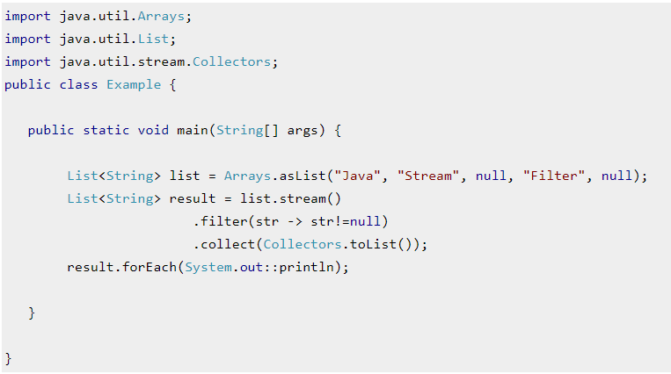

import java.util.Arrays;

import java.util.List;

import java.util.stream.Collectors;

public class Example {

public static void main(String[] args) {

List<String> list = Arrays.asList("Java", "Stream", null, "Filter", null);

List<String> result = list.stream()

.filter(str -> str!=null)

.collect(Collectors.toList());

result.forEach(System.out::println);

}

}

* Base64(Encode-Decode)
* Default Method in Interface
* forEach
* Collectors class
* Optional Class
* JavaScript Nashorn
* Parallel Array Sort
* Type Inference Improvement
* Date Time
* Predicate
* Read File
* Write to File

**Java 9**

* Interface Private Methods
* Try-with resources
* Anonymous Classes
* Collection Factory Methods
* Stream API Improvement
* Modules

**Java 10**

* Type Inference with local variable var

**Java 11**

* String Handling Enhancements
* Lambda Enhancements

**Files.readString()**

**Java 6 and below:**

Java 6 and below uses [BufferedReader](https://docs.oracle.com/javase/7/docs/api/java/io/BufferedReader.html) class.

It’s readLine() method **reads the file one line at a time** and return the content.

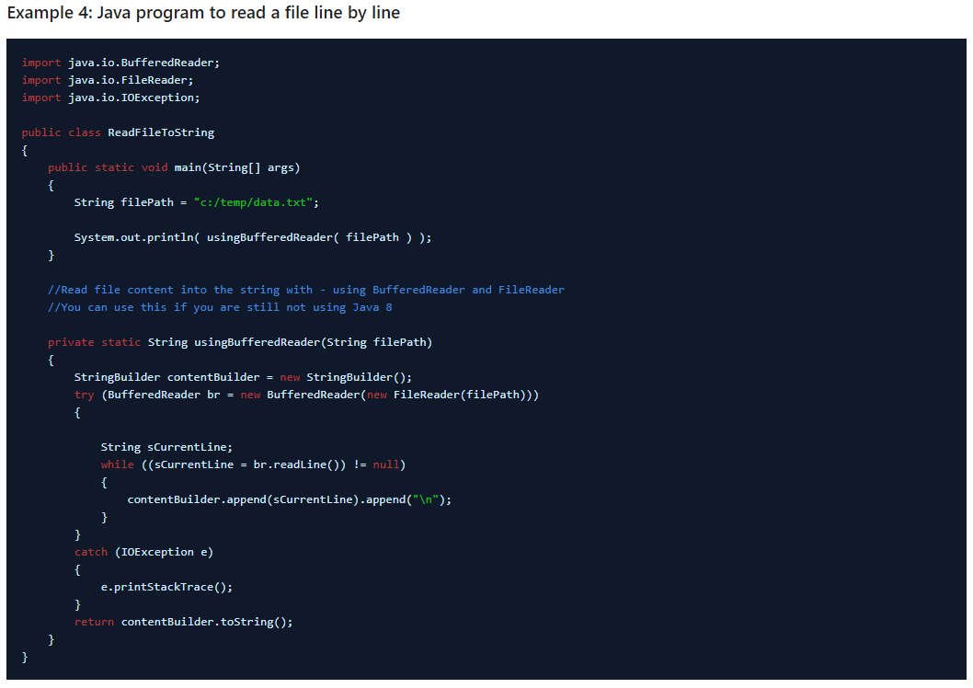

import java.io.BufferedReader;

import java.io.FileReader;

import java.io.IOException;

public class ReadFileToString

{

    public static void main(String[] args)

    {

        String filePath = "c:/temp/data.txt";

        System.out.println( usingBufferedReader( filePath ) );

    }

    //Read file content into the string with - using BufferedReader and FileReader

    //You can use this if you are still not using Java 8

    private static String usingBufferedReader(String filePath)

    {

        StringBuilder contentBuilder = new StringBuilder();

        try (BufferedReader br = new BufferedReader(new FileReader(filePath)))

        {

            String sCurrentLine;

            while ((sCurrentLine = br.readLine()) != null)

            {

                contentBuilder.append(sCurrentLine).append("\n");

            }

        }

        catch (IOException e)

        {

            e.printStackTrace();

        }

        return contentBuilder.toString();

    }

}

**Java 7:**

**Files.readAllBytes() – Read the entire File to String – Java 7**

[readAllBytes()](https://docs.oracle.com/javase/7/docs/api/java/nio/file/Files.html#readAllBytes(java.nio.file.Path)) method reads all the bytes from a file. The method ensures that the file is closed when all bytes have been read or an I/O error, or other runtime exception, is thrown.

After reading all bytes, we pass those bytes to String class constructor to create a string.

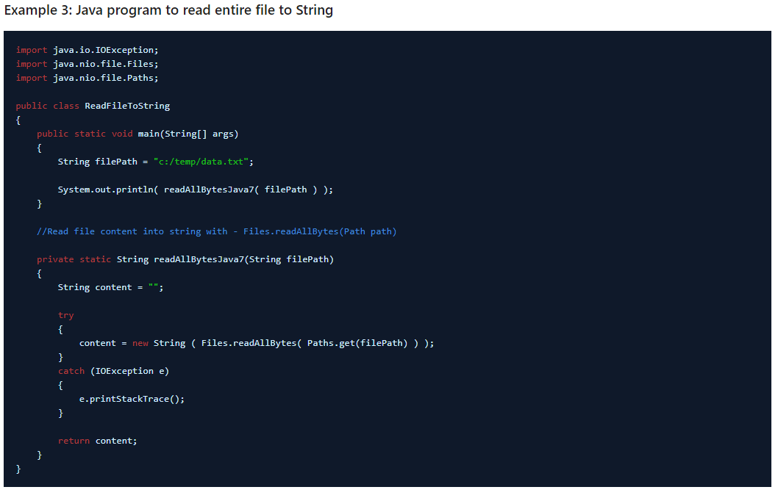

import java.io.IOException;

import java.nio.file.Files;

import java.nio.file.Paths;

public class ReadFileToString

{

    public static void main(String[] args)

    {

        String filePath = "c:/temp/data.txt";

        System.out.println( readAllBytesJava7( filePath ) );

    }

    //Read file content into string with - Files.readAllBytes(Path path)

    private static String readAllBytesJava7(String filePath)

    {

        String content = "";

        try

        {

            content = new String ( Files.readAllBytes( Paths.get(filePath) ) );

        }

        catch (IOException e)

        {

            e.printStackTrace();

        }

        return content;

    }

}

**Java 8:**

**Files.lines() – Java 8**

[lines()](https://docs.oracle.com/javase/8/docs/api/java/nio/file/Files.html#lines-java.nio.file.Path-java.nio.charset.Charset-) method **read all lines from a file to stream** and populates lazily as the [stream](https://howtodoinjava.com/java8/java-streams-by-examples/) is consumed. Bytes from the file are decoded into characters using the specified charset.

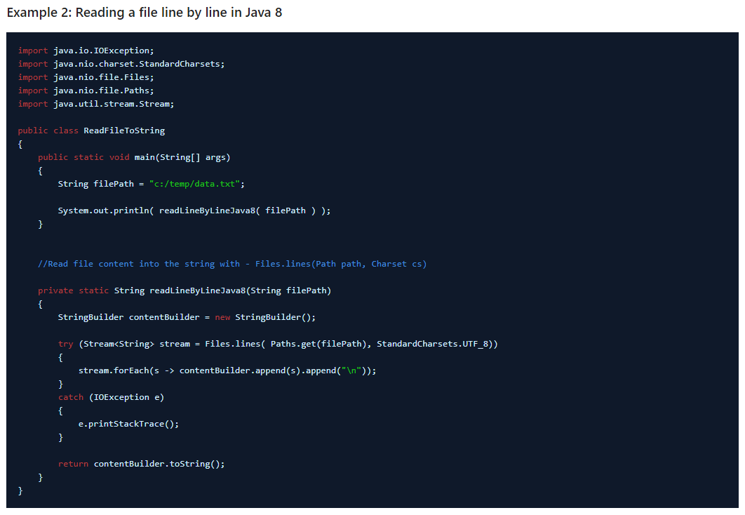

import java.io.IOException;

import java.nio.charset.StandardCharsets;

import java.nio.file.Files;

import java.nio.file.Paths;

import java.util.stream.Stream;

public class ReadFileToString

{

    public static void main(String[] args)

    {

        String filePath = "c:/temp/data.txt";

        System.out.println( readLineByLineJava8( filePath ) );

    }

    //Read file content into the string with - Files.lines(Path path, Charset cs)

    private static String readLineByLineJava8(String filePath)

    {

        StringBuilder contentBuilder = new StringBuilder();

        try (Stream<String> stream = Files.lines( Paths.get(filePath), StandardCharsets.UTF_8))

        {

            stream.forEach(s -> contentBuilder.append(s).append("\n"));

        }

        catch (IOException e)

        {

            e.printStackTrace();

        }

        return contentBuilder.toString();

    }

}

**Java 11:**

**Files.readString() – Java 11**

With the new method [readString()](https://docs.oracle.com/en/java/javase/11/docs/api/java.base/java/nio/file/Files.html#readString(java.nio.file.Path)) introduced in [Java 11](https://howtodoinjava.com/java11/features-enhancements/), it takes only a single line to read a file’s content in to String.

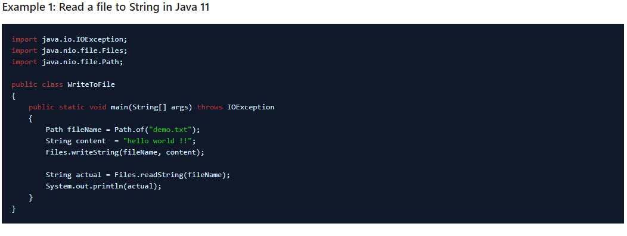

import java.io.IOException;

import java.nio.file.Files;

import java.nio.file.Path;

public class WriteToFile

{

    public static void main(String[] args) throws IOException

    {

        Path fileName = Path.of("demo.txt");

        String content  = "hello world !!";

        Files.writeString(fileName, content);

        String actual = Files.readString(fileName);

        System.out.println(actual);

    }

}

**Files.writeString()**

**Java 11:**

**Files writeString() – Java11**

java.nio.file.Files class has two overloaded [static](https://howtodoinjava.com/java/keywords/java-static-keyword/) methods to write content to file.

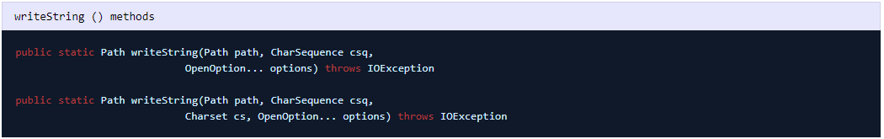

* First method writes all content to a file, using the **UTF-8** charset.
* First method is equivalent to writeString(path, string, StandardCharsets.UTF_8, options).
* Second method does the same with with only using the specified charset.
* options specifies how the file is opened.

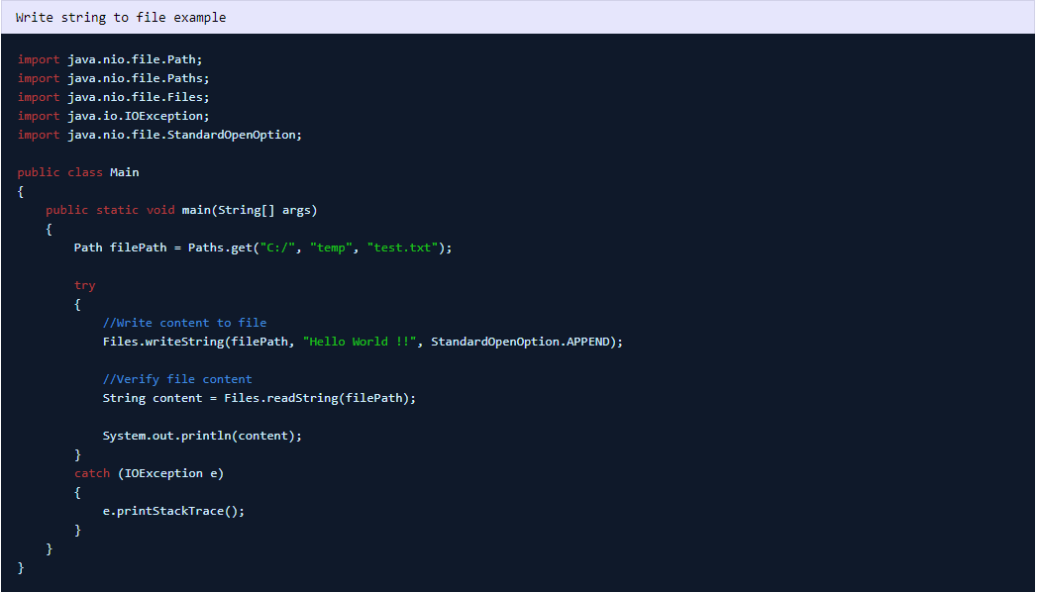

import java.nio.file.Path;

import java.nio.file.Paths;

import java.nio.file.Files;

import java.io.IOException;

import java.nio.file.StandardOpenOption;

public class Main

{

    public static void main(String[] args)

    {

        Path filePath = Paths.get("C:/", "temp", "test.txt");

        try

        {

            //Write content to file

            Files.writeString(filePath, "Hello World !!", StandardOpenOption.APPEND);

            //Verify file content

            String content = Files.readString(filePath);

            System.out.println(content);

        }

        catch (IOException e)

        {

            e.printStackTrace();

        }

    }

}